Dear Families,

Exbourne Church of England Primary School
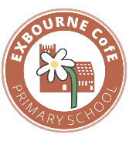
It has been lovely to see how well the children are enjoying the new term. They are all really engaged in their learning and have enjoyed spending time with friends. Olive Class have been working hard in phonics and we have seen lots of progress. The children are also becoming more independent. Dove Class have enjoyed writing letters based on the text ‘The Day the Crayons Quit’ and learning about the Romans. As a school, we have especially enjoyed going swimming and it has been a pleasure to see the children’s confidence grow.
Wrap Around Care
This term saw the introduction of after school club, which has been a great success. The children that attend have all enjoyed the range of activities on offer. You can book using the Parent App or calling the school.
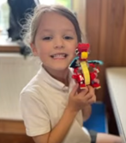
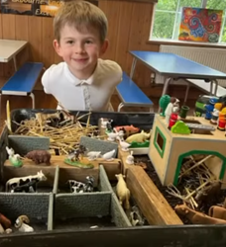

Harvest Festival
Thank you to all those that attended the Harvest Festival and to Rev Jonathan for delivering a lovely service. Well done to all the children for their beautiful singing and delivering prayers and a poem. The PFA are going to purchase a microphone so that our voices will be heard at the back of the church. We were grateful for all the donations, which were taken to Okehampton Food Bank.

Christmas Production
This year, Year 3 and Year 4 are also going to be taking part in the Christmas Nativity. We shall send more news about this soon and are looking forward to watching this exciting production.

After School Events
It was lovely to see so many families at Messy Church. Please be aware that if you are attending an after school event, children are not permitted to play in the playground and must stay with parents for health and safety reasons.
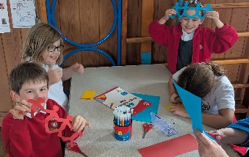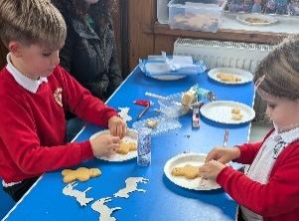

School Admissions
Please note the deadline for applying for a secondary school place is 31st October 2025. The admission’s team no longer write to families inviting applications. Instead, you can apply for your child’s place by visiting - School admissions - Children, families and education
Primary School Admissions are opening in November. If you know anyone who is thinking of choosing our school, please do encourage them to come for a visit. Rather than hold an open morning, we welcome visitors at any point in the school year. This is so families can experience the day-to-day life of our school and see the caring, nurturing environment we provide.

Story and Rhyme Time
Every fortnight, we are holding a story and rhyme time for children under 5. The next session is Wednesday 12th November. Those that attended the first session, spoke very fondly of the event, with one parent commenting that it was the best story session she had been to. Please spread the word as we would love to see more families.
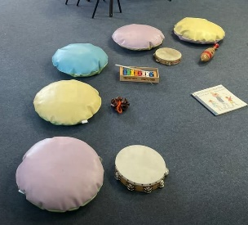
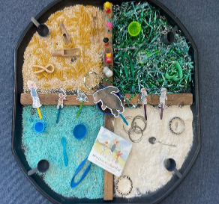
Trips
We have a number of trips next term. Dove Class will be going to Exeter and Olive Class to Knightshayse at Tiverton with children from Bridestowe. We will also be attending a pantomime with children from other small schools in our Trust. We are trying to find ways to ensure that we keep costs to a minimum.
Attendance
You will have received your child’s attendance certificate. As the attendance letter at the start of the term stated, these shall be sent to you twice every half term. If there is anything you would like to discuss about attendance, please do see your child’s teacher.

Finally, thank you for taking the time to read this newsletter. If you have any queries, please do not hesitate to get in touch.

Kind regards
Natasha Birnie
Lead Teacher

Dates for this term:
31.10.25 – deadline for secondary admissions
5.11.25 – Parent Teacher meetings
13.11.25 – Dove Class Trip
14.11.25 – Children in Need
17.12.25 – Christmas Carol Service
19.12.25- Last Day of Term
Term Dates
05.01.25 –Non-pupil Day
06.01.25 – Children return to school
16-20th February – Half term

