Dear Families,

Exbourne Church of England Primary School

We have had a very busy start back – we are whizzing through the half term.
Exeter Cathedral Trip
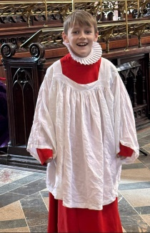
Dove Class had a fantastic trip to Exeter Cathedral, where we were fortunate to be shown around by Canon Kate. We also loved exploring the fascinating exhibits at the RAMM museum. A big thank you to our families for coming to our rescue at Crediton Station when trains were unavailable.
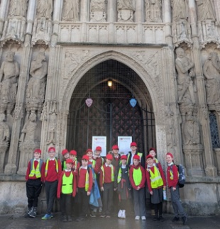

Knightshaye Trip
Olive Class had a wonderful day at National Trust Knightshayes with Tawny Owls Class from Bridestowe Primary School. The children especially loved seeing the beautifully decorated Christmas trees and exploring the stunning gardens.
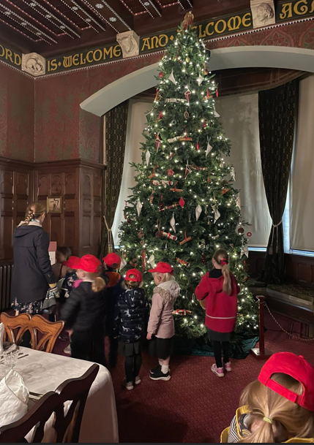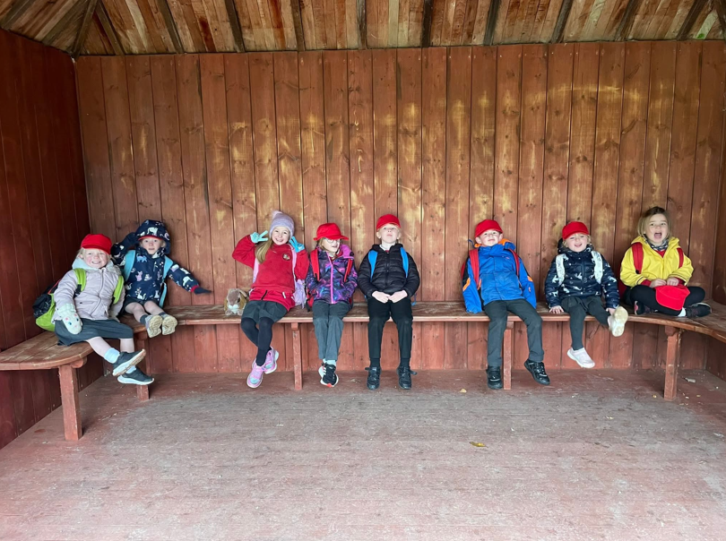
Christmas
As the Christmas season draws closer, we are looking forward to lots of events!
Monday 8th December at 2.30pm and 6pm is our Christmas Nativity Performance ‘Born in a Barn.’
Christmas lunch will be Wednesday 10th December and children are welcome to wear a Christmas jumper or a red top (there is no need to purchase a jumper if you do not already have one).
Friday 12th December Dove Class pantomime trip and Wednesday 17th December Olive Class pantomime trip. Just a reminder that pick up will at 4.30pm from the field. Please check Facebook for updates as we may be back before this.
Wednesday 17th December 9.15 am Christmas Carol Service with tea and coffee in the school hall afterwards.
On Friday, 19th December, children can wear their own clothes as we’ll be celebrating with a Christmas party—and we’re hoping for a very special surprise visitor!
Christmas Messy Play
Join Mrs. Holdsworth for a Festive Messy Play!
📅 Saturday, 13th December
🕙 10:30 AM – 11:30 AM
📍 In school
🎄 For children aged 6 and under. Activities will include:
- Making reindeer food
- Creating Christmas cards
- Frozen animals
And much more! For more information and to book, please visit their Facebook page: Messy Makers SW

PFA
Thank you to the PFA for all their fundraising efforts. This term, they have £855.02 for trips, which is equivalent to £34.20 per child. Without the PFA, we would not have been able to have these enrichment opportunities.
To enable this to continue, the PFA are looking for more parents or family members to join. They get together for coffee every six weeks, with no obligation to join the committee. If you are interested in joining or if you would like to become an ad-hoc volunteer, please let us know.

Deaf Awareness
We have continued to learn sign language as part of our inclusive curriculum. On Wednesday 10th December, Kylie Barker (teacher of the deaf) is delivering a workshop to staff and children to on Peer Deaf Awareness. We are very much looking forward to this.

SEND Forum
All families are invited join us for our upcoming SEND Forum on Monday 1st December at 2.45pm.
It is an opportunity to share your thoughts and experiences and learn more about the support available for children with SEND. Your voice matters, and we’d love to hear from you!

Swimming and P.E Lessons
Please ensure any outstanding swimming balances are paid promptly, as we need to settle the payment with the pool.
In the Spring and Summer terms, P.E. for all children will take place on Thursdays with Tom Rutter. Mr Rutter is a specialist P.E. teacher who has been teaching at Bridestowe and comes highly recommended. We are very excited to welcome him to our school. Dove Class will continue to have P.E on Friday and Olive Class on Wednesdays as well.
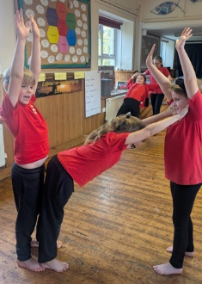
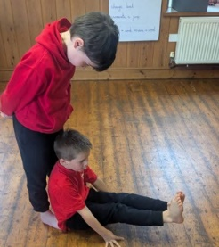

Wrap Around Care
Thank you to everyone who has used our wraparound care. We’re delighted to share that the representative from Devon County Council was very impressed with the quality of service provided. A special thank you to Mrs Holdsworth and Mrs Chapman for their dedication in ensuring the best care for our children.
School Admissions
15th January 2026 is the closing date for reception admissions. We have had several visits from families, but if you know anyone else who is thinking of choosing our school, please do encourage them to come for a visit. Also please do share our poster!

Story and Rhyme Time
Our fortnightly Story and Rhyme Time sessions continue to grow in popularity! Each session is themed around a picture book and includes fun activities and singing. Wednesday 10th December, we are having a special Christmas session. Please help us spread the word—we’d love to see even more families join us!
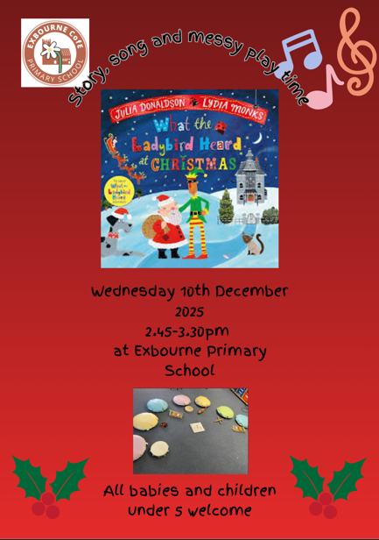

Finally, thank you for taking the time to read this newsletter. If you have any queries, please do not hesitate to get in touch.

Kind regards
Natasha Birnie
Lead Teacher

Dates
01.12.25 – SEND Parent Forum
03.12.25- PFA movie night
08.12.25 – Nativity Performances
09.12.25 – Last swimming session
10.12.25 – Deaf Awareness
10.12.25 – Christmas Lunch
10.12.25 – Christmas Stay and Play
12.12.25 – KS2 Pantomime visit
13.12.25- Festive Messy Play
17.12.25 – Christmas Carol Service
17.12.25 – KS1 Pantomime visit
19.12.25- Last Day of Term
19.12.25 – Christmas Party
Term Dates
05.01.25 –Non-pupil Day
06.01.25 – Children return to school
16-20th February – Half term

