Dear Families,

Exbourne Church of England Primary School
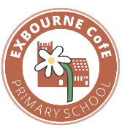
We have had a flying start to the new year! Dove Class have especially enjoyed learning the recorder and creating collagraph printing plates in art. Olive Class have enjoyed learning traditional tales and making poo in science!

School Motto
As part of our ongoing commitment to our values and Church of England identity, we have reviewed our school motto. As a result, “Exbourne: Encouraging Excellence” will be replaced with…
Exbourne: With faith, we flourish and learn.

Well-being Week and Safer Internet Awareness
Children’s Mental Health Awareness week will take place on the 9th-15th February. This year’s theme is ‘This is My Place,’ and our aim is to support children and young people to help them feel like they belong. Children will be participating in lots of activities throughout the week.
On Friday 13th February, the PFA will be having a non-uniform day. Children can wear an outfit which makes them feel most comfortable, confident, and like they truly belong — whether that’s cosy clothes, cultural dress, favourite colours, or something totally unique. Celebrate what makes you, you!
During this week we will also be participating in Safer Internet Day and this year’s theme is AI.

British Science Week
Science is taking over again! We’re excited to take part in British Science Week following last year's success. Every group will complete a unique investigation and then share their results with you at our science fair on. Mark your calendars for Wednesday 11th March, 2.15pm–3.00pm—we look forward to seeing you there!"

Mother’s Day Worship Assembly
Following the Science Fair, we will be holding a special assembly on Wednesday 11th March at 3pm to celebrate our wonderful mummies. We invite all families to join us for this occasion

Coach Tom
This term, we have been delighted to welcome Coach Tom to our school. The children have thoroughly enjoyed his fun
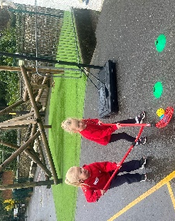
and engaging lessons, whilst learning new skills. Coach Tom will be with us for the remainder of the academic year.
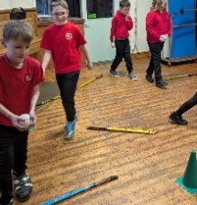

Sign Language Club
Friday’s sign language club with Kylie has been very popular. She has taught the children how to talk about themselves using sign language, as well as a range of useful signs that can be used in class, such as ready and practice.
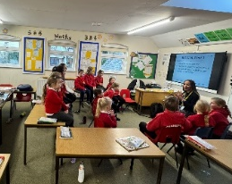
Safeguarding
Ensuring that children are safe both in and out of school remains our highest priority. In school, children learn how to keep themselves safe in the real world and online through lessons and assemblies.
As part of this work, it is important that we gather the views of children, staff and parents. Therefore, in the coming weeks, we will be sending out a safeguarding survey and would be grateful if you could take the time to complete it. Your feedback will help us to make improvements and ensure that we are doing the very best for our children.
School Values and Messy Church
Every month, we hold Messy Church in the school hall. There are fun activities for all ages, a chance to share food and learn more about God’s stories. It is a relaxed and joyful atmosphere and there is no pressure to join in.
This term, the children have been truly inspired through their exploration of the theme of perseverance. They have taken time to consider what perseverance means, what it looks like to them personally, how it is shown within our school community, and how it is demonstrated in the wider world.
Through the Parable of the Lost Sheep, we reflected on how God never gave up searching for those who were lost, reminding us that we, too, should keep going even when things feel challenging. The children have discussed how they can encourage others to persevere and flourish, as well as how they have strengthened their own perseverance over the course of the term.
Reverend Jonathan and Reverend Leigh have led insightful and thought-provoking worship sessions, which the children have engaged with enthusiastically — we are never short of volunteers eager to act out different parts of the Bible stories!

Kind regards
Natasha Birnie
Lead Teacher

Dates
Spring Term
09- 15.02.26 Children’s Mental Health Week and Safer Internet Awareness
13.02.26 – Non-uniform Day
16-20.02.26 Half term
25.02.26 Story, song and messy play
04.03.26 – Parents Evening
05.03.26 – World Book Day
11.03.26 – Science Fair 2.15pm – 3pm
11.03.26 – Mother’s Day assembly 3pm
18.03.26 – SENCO meetings
19.03.16 – Messy Church
25.03.26 – Easter Service
01-02.04.26 - Year 4 residential
02.04.26 – Last Day of Term

Summer Term
20.04.26 - First Day of Term
22-24.04.26 – Year 5 residential
11-14.05.26 SATs week
02-05.06.26 – Y6 residential

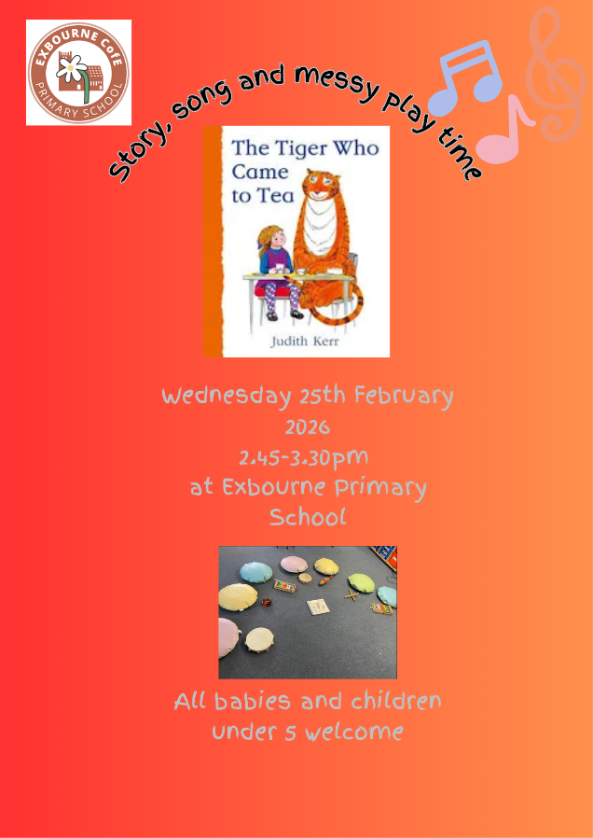

i

